##### Risk and Crisis Communication Talking Points

*Use this form to construct a message to convey situation to stakeholders.*

|  |
| --- |
| **Express Empathy** |
| *Describe how you are concerned for anyone impacted by this situation* |
| **Share Facts** |
| *Share what you know about the situation*  *Who*  *What*  *Where*  *Why*  *When*  *How* |
| **Share Unknowns** |
| *Share what facts are unknown about the situation* |
| **Share Actions Taken and are Taking** |
| *Explain the steps you are taking to get answers to the unknown* |
| **Share Statement of Commitment** |
| *Explain how you are committed to getting answers and solving the problem* |
| **Referrals** |
| *Provide name, number, or website to obtain situation updates and information* |
| **Next Update** |
| *Indicate when next update will be given* |

*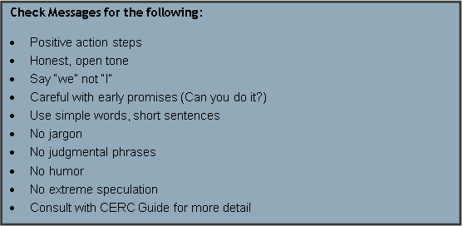Source: Adapted from CERC 2012 Manual*